VISVESVARAYA TECHNOLOGICAL UNIVERSITY

“JnanaSangama”, Belgaum -590014, Karnataka.



LAB REPORT

on

OPERATING SYSTEMS

Submitted by

TANMAY AGARWAL (1WA23CS010)

in partial fulfillment for the award of the degree of

# BACHELOR OF ENGINEERING

in

COMPUTER SCIENCE AND ENGINEERING



B.M.S. COLLEGE OF ENGINEERING

(Autonomous Institution under VTU)

BENGALURU-560019

Feb-2025 to June-2025

B. M. S. College of Engineering,

Bull Temple Road, Bangalore 560019

(Affiliated To Visvesvaraya Technological University, Belgaum)

Department of Computer Science and Engineering



CERTIFICATE

This is to certify that the Lab work entitled “OPERATING SYSTEMS – 23CS4PCOPS” carried out by TANMAY AGARWAL(1WA23CS010), who is Bonafide student of B. M. S. College of Engineering. It is in partial fulfilment for the award of Bachelor of Engineering in Computer Science and Engineering of the Visvesvaraya Technological University, Belgaum during the year Feb 2025- June 2025. The Lab report has been approved as it satisfies the academic requirements in respect of a OPERATING SYSTEMS - (23CS4PCOPS) work prescribed for the said degree.

Dr Seema Patil Dr. Kavitha Sooda

Assistant Professor Professor and Head

Department of CSE Department of CSE

BMSCE, Bengaluru BMSCE, Bengaluru

Index Sheet

|  |  |  |
| --- | --- | --- |
| Sl.  No. | Experiment Title | Page No. |
| 1. | Write a C program to simulate the following non-pre-emptive CPU scheduling algorithm to find turnaround time and waiting time.  →FCFS  → SJF (pre-emptive & Non-preemptive)  → Priority (pre-emptive & Non-pre-emptive)  →Round Robin (Experiment with different quantum sizes for RR algorithm) | 1-9 |
| 2. | Write a C program to simulate multi-level queue scheduling algorithm considering the following scenario. All the processes in the system are divided into two categories – system processes and user processes. System processes are to be given higher priority than user processes. Use FCFS scheduling for the processes in each queue. | 10-18 |
| 3. | Write a C program to simulate Real-Time CPU Scheduling algorithms:   1. Rate- Monotonic 2. Earliest-deadline First   Proportional scheduling | 19-22 |
| 4. | Write a C program to simulate producer-consumer problem using semaphores  and  concept of Dining Philosophers problem. | 23-29 |
| 5. | Write a C program to simulate Bankers algorithm for the  🡪 purpose of deadlock avoidance.  🡪purpose of deadlock detection | 30-32 |
| 6. | Write a C program to simulate the following contiguous memory allocation techniques  a) Worst-fit   1. Best-fit   c)First-fit | 33-35 |
| 7. | Write a C program to simulate page replacement algorithms a) FIFO   1. LRU 2. Optimal | 36- 39 |

Course Outcomes

|  |  |
| --- | --- |
| C01 | Apply the different concepts and functionalities of Operating System |
| C02 | Analyse various Operating system strategies and techniques |
| C03 | Demonstrate the different functionalities of Operating System. |
| C04 | Conduct practical experiments to implement the functionalities of Operating system. |

# **INDEX (COPY)**

# 

# **Program -1**

**Question:**

Write a C program to simulate the following non-pre-emptive CPU scheduling algorithm to find turnaround time and waiting time.

→FCFS

→ SJF (pre-emptive & Non-preemptive)

**Code:**

=>FCFS:

#include<stdio.h>

typedef struct{

    int id, AT, BT, TAT, RT, CT, WT;

}Process;

void sorted(Process p[], int n)

{

    int i, j;

    for(i = 0; i < n-1; i++)

    {

        for(j = 0; j < n-i-1; j++)

        {

            if(p[j].AT > p[j+1].AT)

            {

                Process temp = p[j];

                p[j] = p[j+1];

                p[j+1] = temp;

            }

        }

    }

}

void FCFS(Process p[], int n)

{

    int TotalTAT = 0, TotalWT = 0, time = 0, i;

    for(i = 0; i < n; i++)

    {

        if(time < p[i].AT)

        {

            time = p[i].AT;

        }

        p[i].CT = time + p[i].BT;

        p[i].TAT = p[i].CT - p[i].AT;

        p[i].WT = p[i].TAT - p[i].BT;

        TotalTAT += p[i].TAT;

        TotalWT += p[i].WT;

        time = p[i].CT;

    }//tanmay

    float avgTAT = (float)TotalTAT / n;

    float avgWT = (float)TotalWT / n;

    printf("Average TurnAround Time: %f\n", avgTAT);

    printf("Average Waiting Time: %f\n", avgWT);

}

int main()

{//tanmay

    int n, i;

    printf("Enter the number of processes: ");

    scanf("%d", &n);

    Process p[n];

    for(i = 0; i < n; i++)

    {

        p[i].id = i+1;

        printf("Enter arrival time and burst time for process %d: ", i+1);

        scanf("%d %d", &p[i].AT, &p[i].BT);

    }

    sorted(p, n);

    FCFS(p, n);

    return 0;

}//tanmay

**Result:**

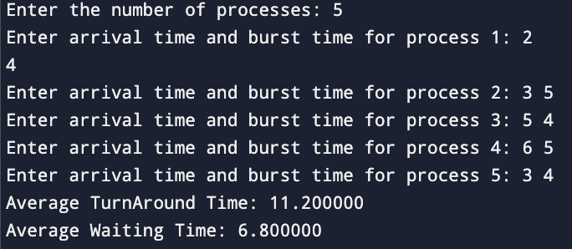

**Copy:**

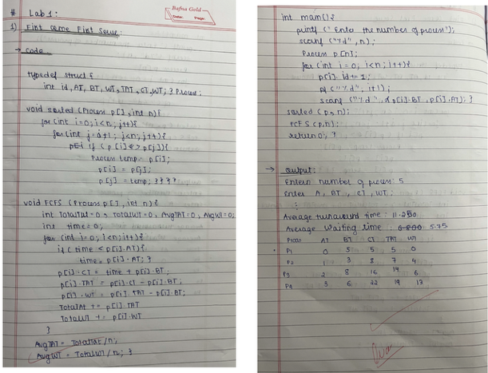

**=>SJF(Non-preemptive):**

**Code:**

#include<stdio.h>

typedef struct {

    int id, AT, BT, TAT, CT, WT;

    int completed; // flag to check if process is done

} Process;

void sorted(Process p[], int n)

{

    int i, j;

    for(i = 0; i < n - 1; i++)

    {

        for(j = 0; j < n - i - 1; j++)

        {

            if(p[j].AT > p[j+1].AT)

            {

                Process temp = p[j];

                p[j] = p[j+1];

                p[j+1] = temp;

            }

        }

    }

}

void SJFNonPreemptive(Process p[], int n)

{

    int TotalTAT = 0, TotalWT = 0, time = 0, completed = 0;

    while(completed < n)

    {

        int minBTIndex = -1;

        int minBT = 9999;

        for(int i = 0; i < n; i++)

        {

            if(p[i].AT <= time && !p[i].completed && p[i].BT < minBT)

            {

                minBT = p[i].BT;

                minBTIndex = i;

            }

        }

        if(minBTIndex != -1)

        {

            time += p[minBTIndex].BT;

            p[minBTIndex].CT = time;

            p[minBTIndex].TAT = p[minBTIndex].CT - p[minBTIndex].AT;

            p[minBTIndex].WT = p[minBTIndex].TAT - p[minBTIndex].BT;

            TotalTAT += p[minBTIndex].TAT;

            TotalWT += p[minBTIndex].WT;

            p[minBTIndex].completed = 1;

            completed++;

        }

        else

        {

            time++;

        }

    }

    float avgTAT = (float)TotalTAT / n;

    float avgWT = (float)TotalWT / n;

    printf("Average TurnAround Time: %f\n", avgTAT);

    printf("Average Waiting Time: %f\n", avgWT);

}

int main()

{

    int n;

    printf("Enter the number of processes: ");

    scanf("%d", &n);

    Process p[n];

    for(int i = 0; i < n; i++)

    {

        p[i].id = i + 1;

        p[i].completed = 0;

        printf("Enter arrival time and burst time for process %d: ", i + 1);

        scanf("%d %d", &p[i].AT, &p[i].BT);

    }

    sorted(p, n);

    SJFNonPreemptive(p, n);

    return 0;

}

**Result:**

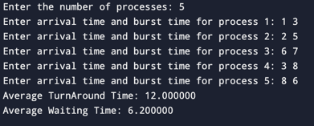

**Copy:**  
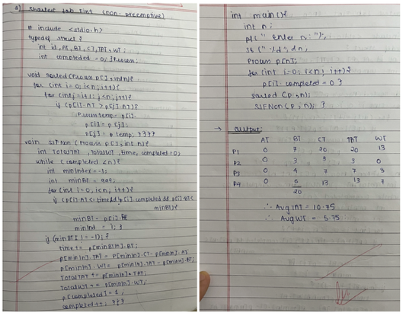

=>SJF(Preemptive):

**Code:**

#include<stdio.h>

typedef struct{

    int id, AT, BT, TAT, RT, CT, WT, tempBT;

}Process;

void sorted(Process p[], int n)

{

    int i, j;

    for(i = 0; i < n-1; i++)

    {

        for(j = 0; j < n-i-1; j++)

        {

            if(p[j].AT > p[j+1].AT)

            {

                Process temp = p[j];

                p[j] = p[j+1];

                p[j+1] = temp;

            }

        }

    }

}

void SJFPreemptive(Process p[], int n)

{

    int TotalTAT = 0, TotalWT = 0, time = 0, completed = 0, i, minBTIndex;

    int remainingBT[n];

    for(i = 0; i < n; i++)

    {

        remainingBT[i] = p[i].BT;

    }

    while(completed < n)

    {

        minBTIndex = -1;

        int minBT = 9999;

        for(i = 0; i < n; i++)

        {

            if(p[i].AT <= time && remainingBT[i] > 0 && remainingBT[i] < minBT)

            {

                minBT = remainingBT[i];

                minBTIndex = i;

            }

        }

        if(minBTIndex != -1)

        {

            remainingBT[minBTIndex]--;

            time++;

            if(remainingBT[minBTIndex] == 0)

            {

                completed++;

                p[minBTIndex].CT = time;

                p[minBTIndex].TAT = p[minBTIndex].CT - p[minBTIndex].AT;

                p[minBTIndex].WT = p[minBTIndex].TAT - p[minBTIndex].BT;

                TotalTAT += p[minBTIndex].TAT;

                TotalWT += p[minBTIndex].WT;

            }

        }

        else

        {

            time++;

        }

    }

    float avgTAT = (float)TotalTAT / n;

    float avgWT = (float)TotalWT / n;

    printf("Average TurnAround Time: %f\n", avgTAT);

    printf("Average Waiting Time: %f\n", avgWT);

}

int main()

{

    int n, i;

    printf("Enter the number of processes: ");

    scanf("%d", &n);

    Process p[n];

    for(i = 0; i < n; i++)

    {

        p[i].id = i+1;

        printf("Enter arrival time and burst time for process %d: ", i+1);

        scanf("%d %d", &p[i].AT, &p[i].BT);

    }

    sorted(p, n);

    SJFPreemptive(p, n);

    return 0;

}

Result:

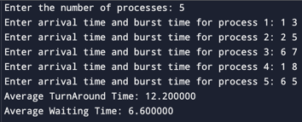

**Copy:**  
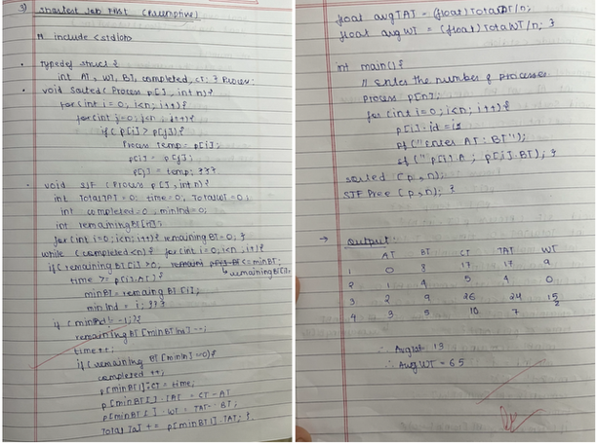

**Program -2**

**Question:**

Write a C program to simulate the following CPU scheduling algorithm to find turnaround time and waiting time.

→ Priority (pre-emptive & Non-pre-emptive)

→Round Robin (Experiment with different quantum sizes for RR algorithm)

=>Priority(Preemptive):

**Code:**

#include <stdio.h>

// TANMAY 1WA23CS010

typedef struct {

    int at, bt, pt, ct, tat, wt, rt, done;

} P;

void sort(P p[], int n) {

    for (int i = 0; i < n - 1; i++) {

        for (int j = i + 1; j < n; j++) {

            if (p[i].at > p[j].at) {

                P temp = p[i];

                p[i] = p[j];

                p[j] = temp;

            }

        }

    }

}

void preemptive(P p[], int n) {

    int t = 0, comp = 0, tatSum = 0, wtSum = 0;

    int rem[n];

    for (int i = 0; i < n; i++) rem[i] = p[i].bt;

    int firstRun[n];

    for (int i = 0; i < n; i++) firstRun[i] = -1;

    while (comp < n) {

        int idx = -1, minP = 9999;

        for (int i = 0; i < n; i++) {

            if (p[i].at <= t && rem[i] > 0 && p[i].pt < minP) {

                minP = p[i].pt;

                idx = i;

            }

        }

        if (idx != -1) {

            if (firstRun[idx] == -1)

                p[idx].rt = t - p[idx].at;

            rem[idx]--;

            if (rem[idx] == 0) {

                comp++;

                p[idx].ct = t + 1;

                p[idx].tat = p[idx].ct - p[idx].at;

                p[idx].wt = p[idx].tat - p[idx].bt;

                tatSum += p[idx].tat;

                wtSum += p[idx].wt;

            }

        }

        t++;  // <-- This line was missing in the faulty version

    }

    printf("ID\tAT\tBT\tPR\tCT\tTAT\tWT\tRT\n");

    for (int i = 0; i < n; i++) {

        printf("%d\t%d\t%d\t%d\t%d\t%d\t%d\t%d\n",

            i + 1, p[i].at, p[i].bt, p[i].pt, p[i].ct, p[i].tat, p[i].wt, p[i].rt);

    }

    printf("\nAverage TurnAround Time: %.2f\n", (float)tatSum / n);

    printf("Average Waiting Time: %.2f\n", (float)wtSum / n);

}

int main() {

    int n;

    printf("Enter number of processes: ");

    scanf("%d", &n);

    P p[n];

    for (int i = 0; i < n; i++) {

        printf("Enter AT, BT, PR for P%d: ", i + 1);

        scanf("%d %d %d", &p[i].at, &p[i].bt, &p[i].pt);

        p[i].done = 0;

    }

    sort(p, n);

    preemptive(p, n);

// TANMAY 1WA23CS010

    return 0;

}

**Result:**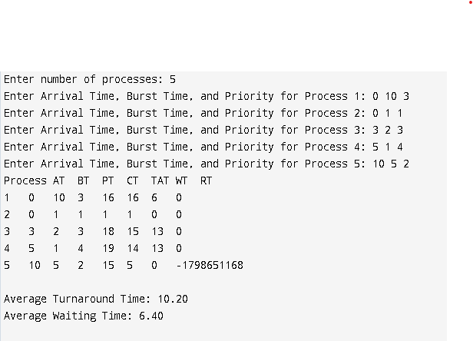

**Copy:**

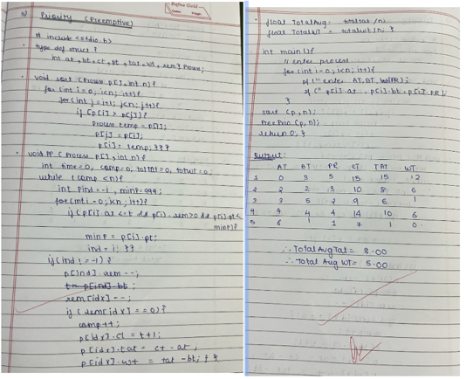Code:

=>Priority(Non-Preemptive):

**Code:**

#include <stdio.h>

// TANMAY 1WA23CS010

typedef struct {

    int id, at, bt, pr, tat, ct, wt;

} P;

void sort(P p[], int n) {

    for (int i = 0; i < n - 1; i++) {

        for (int j = 0; j < n - i - 1; j++) {

            if (p[j].at > p[j + 1].at) {

                P temp = p[j];

                p[j] = p[j + 1];

                p[j + 1] = temp;

            }

        }

    }

}

void schedule(P p[], int n) {

    int tatSum = 0, wtSum = 0, t = 0, done = 0;

    int comp[n];

    for (int i = 0; i < n; i++) comp[i] = 0;

    while (done < n) {

        int idx = -1, minPr = 9999;

        for (int i = 0; i < n; i++) {

            if (p[i].at <= t && !comp[i] && p[i].pr < minPr) {

                minPr = p[i].pr;

                idx = i;

            }

        }

        if (idx != -1) {

            t += p[idx].bt;

            p[idx].ct = t;

            p[idx].tat = p[idx].ct - p[idx].at;

            p[idx].wt = p[idx].tat - p[idx].bt;

            tatSum += p[idx].tat;

            wtSum += p[idx].wt;

            comp[idx] = 1;

            done++;

        } else {

            t++;

        }

    }

// TANMAY 1WA23CS010

    float avgTAT = (float)tatSum / n;

    float avgWT = (float)wtSum / n;

    printf("Average TurnAround Time: %.2f\n", avgTAT);

    printf("Average Waiting Time: %.2f\n", avgWT);

}

int main() {

    int n;

    printf("Enter the number of processes: ");

    scanf("%d", &n);

    P p[n];

    for (int i = 0; i < n; i++) {

        p[i].id = i + 1;

        printf("Enter arrival time, burst time, and priority for process %d: ", i + 1);

        scanf("%d %d %d", &p[i].at, &p[i].bt, &p[i].pr);

    }

    sort(p, n);

    schedule(p, n);

    return 0;

}

**Result:**  
  
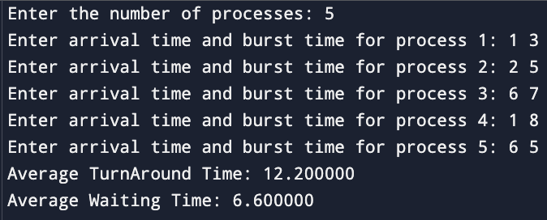

**Copy:**   
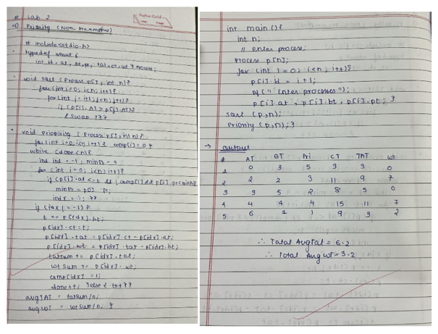

**Code:**

=>RoundRobin:

#include <stdio.h>

#include <stdlib.h>

// TANMAY 1WA23CS010

typedef struct Process {

    int AT, BT, CT, TAT, WT, RT, remainingBT, finished;

} Process;

void Sort(Process p[], int n) {

    Process temp;

    for (int i = 0; i < n - 1; i++) {

        for (int j = i + 1; j < n; j++) {

            if (p[i].AT > p[j].AT) {

                temp = p[i];

                p[i] = p[j];

                p[j] = temp;

            }

        }

    }

}

void RoundRobin(Process p[], int n, int quantum) {

    int time = 0, completed = 0, totalTAT = 0, totalWT = 0;

    // Queue for processes that need to be executed

    int queue[n], front = 0, rear = 0;

    for (int i = 0; i < n; i++) {

        p[i].remainingBT = p[i].BT;

        p[i].finished = 0;

    }

    while (completed < n) {

        int flag = 0;

        // Add processes to queue if they have arrived

        for (int i = 0; i < n; i++) {

            if (p[i].AT <= time && p[i].finished == 0) {

                queue[rear++] = i;

                p[i].finished = 1; // Mark process as added to queue

            }

        }

        // Process execution

        if (front < rear) {

            int ind = queue[front++];

            if (p[ind].remainingBT > quantum) {

                time += quantum;

                p[ind].remainingBT -= quantum;

                queue[rear++] = ind; // Put back the process in the queue

            } else {

                time += p[ind].remainingBT;

                p[ind].remainingBT = 0;

                p[ind].CT = time;

                p[ind].TAT = p[ind].CT - p[ind].AT;

                p[ind].WT = p[ind].TAT - p[ind].BT;

                totalTAT += p[ind].TAT;

                totalWT += p[ind].WT;

                completed++;

            }

            flag = 1;

        }

// TANMAY 1WA23CS010

        // If no process is executing, increment time

        if (flag == 0) {

            time++;

        }

    }

    // Printing the results

    printf("Process\tAT\tBT\tCT\tTAT\tWT\tRT\n");

    for (int i = 0; i < n; i++) {

        printf("%d\t%d\t%d\t%d\t%d\t%d\t%d\n", i + 1, p[i].AT, p[i].BT, p[i].CT, p[i].TAT, p[i].WT, p[i].RT);

    }

// TANMAY 1WA23CS010

    printf("\nAverage Turnaround Time: %.2f\n", (float)totalTAT / n);

    printf("Average Waiting Time: %.2f\n", (float)totalWT / n);

}

int main() {

    int n, quantum;

    printf("Enter number of processes: ");

    scanf("%d", &n);

    Process p[n];

    for (int i = 0; i < n; i++) {

        printf("Enter Arrival Time and Burst Time for Process %d: ", i + 1);

        scanf("%d %d", &p[i].AT, &p[i].BT);

        p[i].remainingBT = p[i].BT;

    }

// TANMAY 1WA23CS010

    printf("Enter the time quantum: ");

    scanf("%d", &quantum);

// TANMAY 1WA23CS010

    Sort(p, n);

    RoundRobin(p, n, quantum);

    return 0;

}

**Result:**   
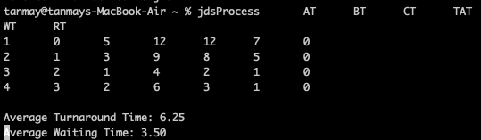

**Copy:**  
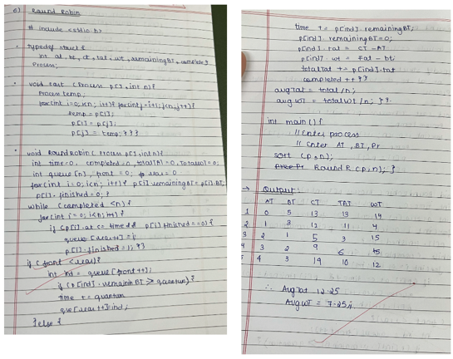

Program -3

Question:

Write a C program to simulate multi-level queue scheduling algorithm considering the following scenario. All the processes in the system are divided into two categories – system processes and user processes. System processes are to be given higher priority than user processes. Use FCFS scheduling for the processes in each queue.

Code:

#include <stdio.h>

typedef struct {

    int pid, AT, BT, CT, TAT, WT, queue, remaining, completed;

} Process;

void Sort(Process p[], int n) {

    for (int i = 0; i < n; i++) {

        for (int j = i+1; j < n; j++) {

            if (p[i].AT > p[j].AT) {

                Process temp = p[i];

                p[i] = p[j];

                p[j] = temp;

            }

        }

        p[i].completed = 0;

        p[i].remaining = p[i].BT;

    }

}

int FCFS(Process p[], int n, int time) {

    for (int i = 0; i < n; i++) {

        if (p[i].queue == 2 && p[i].completed == 0) {

            if (time < p[i].AT) {

                time = p[i].AT;

            }

            p[i].CT = time + p[i].BT;

            p[i].TAT = p[i].CT - p[i].AT;

            p[i].WT = p[i].TAT - p[i].BT;

            p[i].completed = 1;

            time = p[i].CT;

            printf("%d\t%d\t\t%d\t\t%d\n", p[i].pid, p[i].WT, p[i].TAT, p[i].WT);

        }

    }

    return time;

}

int RoundRobin(Process p[], int n, int quantum, int time) {

    int done = 0;

    while (done == 0) {

        done = 1;

        for (int i = 0; i < n; i++) {

            if (p[i].queue == 1 && p[i].completed == 0 && p[i].AT <= time) {

                done = 0;

                if (p[i].remaining > quantum) {

                    time += quantum;

                    p[i].remaining -= quantum;

                } else {

                    time += p[i].remaining;

                    p[i].remaining = 0;

                    p[i].completed = 1;

                    p[i].CT = time;

                    p[i].TAT = p[i].CT - p[i].AT;

                    p[i].WT = p[i].TAT - p[i].BT;

                    printf("%d\t%d\t\t%d\t\t%d\n", p[i].pid, p[i].WT, p[i].TAT, p[i].WT);

                }

            }

        }

    }

    return time;

}

int main() {

    int n, quantum = 2;

    printf("Queue 1 is system process\n");

    printf("Queue 2 is User Process\n");

    printf("Enter number of processes: ");

    scanf("%d", &n);

    Process p[n];

    for (int i = 0; i < n; i++) {

        p[i].pid = i+1;

        printf("Enter Burst Time, Arrival Time and Queue of P%d: ", i+1);

        scanf("%d %d %d", &p[i].BT, &p[i].AT, &p[i].queue);

    }

    Sort(p, n);

    int time = 0;

    printf("\nProcess\tWaiting Time\tTurn Around Time\tResponse Time\n");

    // Execute Queue 1 (RR) first and get updated time

    time = RoundRobin(p, n, quantum, time);

    // Then execute Queue 2 (FCFS) and get updated time

    time = FCFS(p, n, time);

    // Calculate averages

    float avgWT = 0, avgTAT = 0, avgRT = 0;

    for (int i = 0; i < n; i++) {

        avgWT += p[i].WT;

        avgTAT += p[i].TAT;

        avgRT += p[i].WT; // Response time same as waiting time in this case

    }

    printf("\nAverage Waiting Time: %.2f\n", avgWT/n);

    printf("Average Turn Around Time: %.2f\n", avgTAT/n);

    printf("Average Response Time: %.2f\n", avgRT/n);

    printf("Throughput: %.2f\n", (float)n/p[n-1].CT);

    return 0;

}

Result:  
  
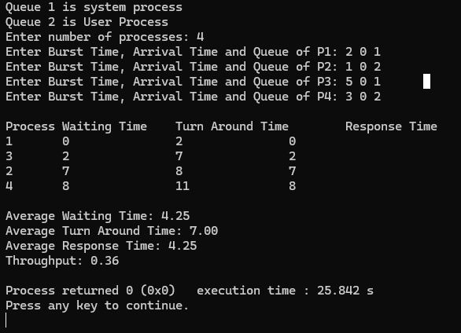

Copy:

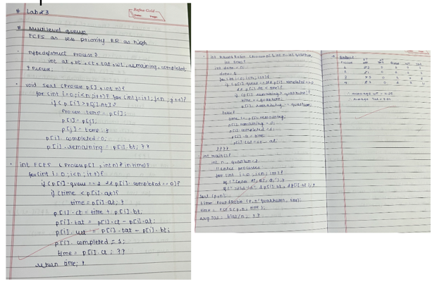

**Program -4**

Question:

Write a C program to simulate Real-Time CPU Scheduling algorithms:

1. Rate- Monotonic
2. Earliest-deadline First

Code:

= > Rate Monotonic  
  
#include <stdio.h>

#define MAX_TASKS 10

typedef struct {

    int id;

    int exec_time;

    int period;

    int remaining;

} Task;

// Function to sort tasks by period (ascending order)

void sortTasksByPeriod(Task tasks[], int n) {

    for (int i = 0; i < n-1; i++) {

        for (int j = 0; j < n-i-1; j++) {

            if (tasks[j].period > tasks[j+1].period) {

                // Swap tasks

                Task temp = tasks[j];

                tasks[j] = tasks[j+1];

                tasks[j+1] = temp;

            }

        }

    }

}

void schedule(Task tasks[], int n, int hyperperiod) {

    printf("\nTime\tTask\n");

    for (int t = 0; t < hyperperiod; t++) {

        int task_to_run = -1;

        // Find first task with remaining work (already in priority order)

        for (int i = 0; i < n; i++) {

            if (tasks[i].remaining > 0) {

                task_to_run = i;

                break;

            }

        }

        if (task_to_run != -1) {

            tasks[task_to_run].remaining--;

            printf("%d\tT%d\n", t, tasks[task_to_run].id);

        } else {

            printf("%d\tIDLE\n", t);

        }

        // Reset tasks at start of their periods

        for (int i = 0; i < n; i++) {

            if ((t + 1) % tasks[i].period == 0) {

                tasks[i].remaining = tasks[i].exec_time;

            }

        }

    }

}

int main() {

    Task tasks[MAX_TASKS];

    int n, hyperperiod;

    printf("Number of tasks (max %d): ", MAX_TASKS);

    scanf("%d", &n);

    for (int i = 0; i < n; i++) {

        tasks[i].id = i + 1;

        printf("T%d execution time: ", i + 1);

        scanf("%d", &tasks[i].exec_time);

        printf("T%d period: ", i + 1);

        scanf("%d", &tasks[i].period);

        tasks[i].remaining = tasks[i].exec_time;

    }

    // Sort tasks by period (Rate Monotonic priority order)

    sortTasksByPeriod(tasks, n);

    printf("Hyperperiod (LCM of all periods): ");

    scanf("%d", &hyperperiod);

    schedule(tasks, n, hyperperiod);

    return 0;

}

Result:  
  
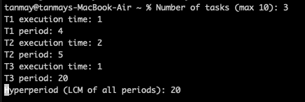

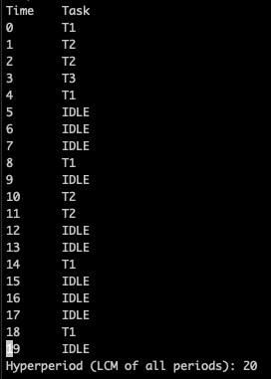

**Copy:**

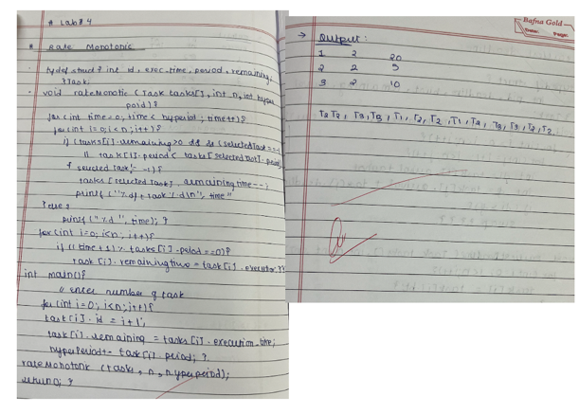

Code:

= > Earliest Deadline:

#include <stdio.h>

#define MAX_TASKS 10

#define MAX_INSTANCES 100

typedef struct {

    int pid;            // Task ID

    int arrival;        // Arrival time

    int deadline;       // Relative deadline

    int abs_deadline;   // Absolute deadline (arrival + deadline)

    int burst;          // Total execution time

    int remaining;      // Remaining execution time

} Task;

// Function to perform Earliest Deadline First scheduling

void earliestDeadlineFirst(Task instances[], int inst_count, int sim_time) {

    printf("\nEarliest Deadline First Scheduling:\n");

    printf("Time\tTask\n");

    for (int time = 0; time < sim_time; time++) {

        int selected = -1;

        int min_deadline = 1e9;

        // Find the task with the earliest absolute deadline that is ready

        for (int i = 0; i < inst_count; i++) {

            if (instances[i].arrival <= time && instances[i].remaining > 0 &&

                instances[i].abs_deadline < min_deadline) {

                min_deadline = instances[i].abs_deadline;

                selected = i;

            }

        }

        if (selected != -1) {

            instances[selected].remaining--;

            printf("%d\tT%d\n", time, instances[selected].pid);

        } else {

            printf("%d\tIdle\n", time);

        }

    }

}

int main() {

    int n, sim_time;

    Task instances[MAX_INSTANCES];

    int inst_count = 0;

    printf("Enter number of tasks: ");

    scanf("%d", &n);

    int period[MAX_TASKS], deadline[MAX_TASKS], burst[MAX_TASKS];

    // Input task details

    for (int i = 0; i < n; i++) {

        printf("Enter Burst, Deadline, Period for Task T%d: ", i + 1);

        scanf("%d %d %d", &burst[i], &deadline[i], &period[i]);

    }

    printf("Enter total simulation time: ");

    scanf("%d", &sim_time);

    // Generate task instances

    for (int i = 0; i < n; i++) {

        for (int t = 0; t < sim_time; t += period[i]) {

            instances[inst_count++] = (Task){

                .pid = i + 1,

                .arrival = t,

                .burst = burst[i],

                .remaining = burst[i],

                .deadline = deadline[i],

                .abs_deadline = t + deadline[i]

            };

        }

    }

    // Call the EDF scheduler

    earliestDeadlineFirst(instances, inst_count, sim_time);

    return 0;

}

**Result :**

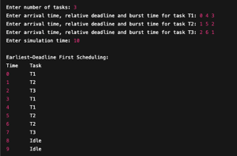

Copy:

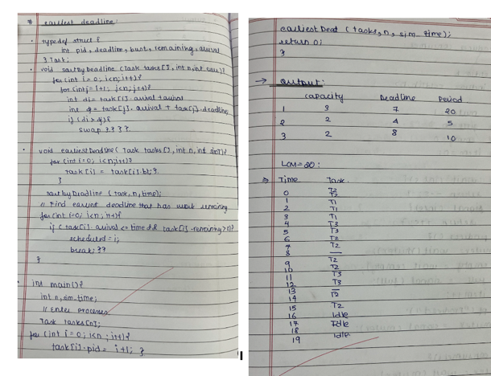

**Program -5**

Question:

Write a C program to simulate producer-consumer problem using semaphores

**Code:**

#include <stdio.h>

#include <stdlib.h>

int mutex = 1;

int full = 0;

int empty = 5;

int item = 0;

int wait(int s);

int signal(int s);

void producer();

void consumer();

int main() {

    int choice;

    printf("Producer-Consumer Problem Simulation\n");

    while (1) {

        printf("\n1. Produce\n2. Consume\n3. Exit\n");

        printf("Enter your choice: ");

        scanf("%d", &choice);

        switch (choice) {

            case 1:

                if ((mutex == 1) && (empty != 0)) {

                    producer();

                } else {

                    printf("Buffer is full or mutex is locked. Cannot produce.\n");

                }

                break;

            case 2:

                if ((mutex == 1) && (full != 0)) {

                    consumer();

                } else {

                    printf("Buffer is empty or mutex is locked. Cannot consume.\n");

                }

                break;

            case 3:

                exit(0);

            default:

                printf("Invalid choice. Try again.\n");

        }

    }

    return 0;

}

int wait(int s) {

    return --s;

}

int signal(int s) {

    return ++s;

}

void producer() {

    mutex = wait(mutex);

    empty = wait(empty);

    full = signal(full);

    item++;

    printf("Produced item %d\n", item);

    mutex = signal(mutex);

}

void consumer() {

    mutex = wait(mutex);

    full = wait(full);

    empty = signal(empty);

    printf("Consumed item %d\n", item);

    item--;

    mutex = signal(mutex);

}

Result:

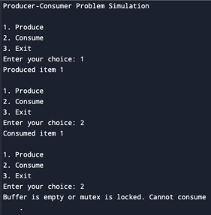

Copy:

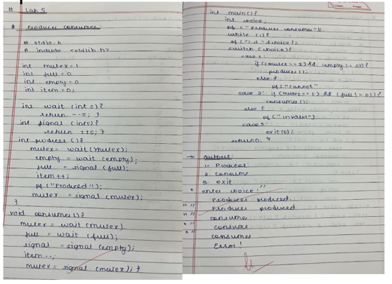

Problem 6:

Question:

Write a C program to simulate the concept of Dining Philosophers problem.

Code:

#include <stdio.h>

#include <pthread.h>

#include <semaphore.h>

#include <unistd.h>

#include <stdlib.h>

#define N 5 // Number of philosophers

#define MEALS 3 // Number of meals per philosopher

sem_t chopsticks[N];

void* philosopher(void* num) {

    int id = *(int*)num;

    int left = id;

    int right = (id + 1) % N;

    int meals_eaten = 0;

    while (meals_eaten < MEALS) {

        // Thinking

        printf("Philosopher %d is thinking...\n", id);

        sleep(1 + rand() % 3);

        // Hungry - try to get chopsticks

        printf("Philosopher %d is hungry\n", id);

        if (id % 2 == 0) {

            // Even philosopher: right then left

            sem_wait(&chopsticks[right]);

            printf("\tPhilosopher %d picked up right chopstick %d\n", id, right);

            usleep(100000); // Small delay

            sem_wait(&chopsticks[left]);

            printf("\tPhilosopher %d picked up left chopstick %d\n", id, left);

        } else {

            // Odd philosopher: left then right

            sem_wait(&chopsticks[left]);

            printf("\tPhilosopher %d picked up left chopstick %d\n", id, left);

            usleep(100000); // Small delay

            sem_wait(&chopsticks[right]);

            printf("\tPhilosopher %d picked up right chopstick %d\n", id, right);

        }

        // Eating

        printf("Philosopher %d is eating (meal %d/%d)\n", id, meals_eaten+1, MEALS);

        sleep(1 + rand() % 2);

        meals_eaten++;

        // Release chopsticks

        sem_post(&chopsticks[left]);

        sem_post(&chopsticks[right]);

        printf("\tPhilosopher %d put down chopsticks %d and %d\n", id, left, right);

    }

    printf("Philosopher %d finished all meals and left\n", id);

    return NULL;

}

int main() {

    pthread_t philosophers[N];

    int ids[N];

    srand(time(NULL));

    // Initialize semaphores

    for (int i = 0; i < N; i++) {

        sem_init(&chopsticks[i], 0, 1);

    }

    // Create philosopher threads

    for (int i = 0; i < N; i++) {

        ids[i] = i;

        pthread_create(&philosophers[i], NULL, philosopher, &ids[i]);

    }

    // Wait for all threads to finish

    for (int i = 0; i < N; i++) {

        pthread_join(philosophers[i], NULL);

    }

    // Cleanup

    for (int i = 0; i < N; i++) {

        sem_destroy(&chopsticks[i]);

    }

    printf("All philosophers finished eating. No deadlock occurred.\n");

    return 0;

}

Result:  
  
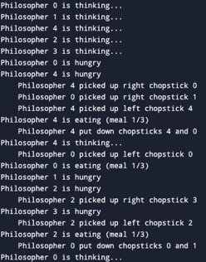

Copy:

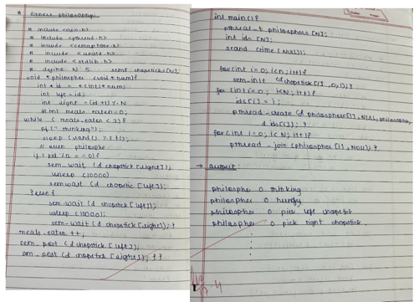

**Problem 7:**

Question:  
Write a C program to simulate Bankers algorithm for the purpose of deadlock avoidance.

Code:

#include <stdio.h>

#include <stdbool.h>

#define MAX_PROCESSES 10

#define MAX_RESOURCES 10

int main() {

    int n, m; // Number of processes and resources

    int alloc[MAX_PROCESSES][MAX_RESOURCES];

    int max[MAX_PROCESSES][MAX_RESOURCES];

    int avail[MAX_RESOURCES];

    int need[MAX_PROCESSES][MAX_RESOURCES];

    bool finish[MAX_PROCESSES] = {false};

    int safeSeq[MAX_PROCESSES];

    int count = 0;

    // Input number of processes and resources

    printf("Enter number of processes (max %d): ", MAX_PROCESSES);

    scanf("%d", &n);

    printf("Enter number of resources (max %d): ", MAX_RESOURCES);

    scanf("%d", &m);

    // Input allocation matrix

    printf("\nEnter allocation matrix (%d processes x %d resources):\n", n, m);

    for (int i = 0; i < n; i++) {

        printf("Process P%d allocations: ", i);

        for (int j = 0; j < m; j++) {

            scanf("%d", &alloc[i][j]);

        }

    }

    // Input maximum matrix

    printf("\nEnter maximum requirement matrix (%d processes x %d resources):\n", n, m);

    for (int i = 0; i < n; i++) {

        printf("Process P%d maximum needs: ", i);

        for (int j = 0; j < m; j++) {

            scanf("%d", &max[i][j]);

        }

    }

    // Input available resources

    printf("\nEnter available resources (%d values): ", m);

    for (int i = 0; i < m; i++) {

        scanf("%d", &avail[i]);

    }

    // Calculate need matrix

    for (int i = 0; i < n; i++) {

        for (int j = 0; j < m; j++) {

            need[i][j] = max[i][j] - alloc[i][j];

        }

    }

    // Find safe sequence

    while (count < n) {

        bool found = false;

        for (int i = 0; i < n; i++) {

            if (!finish[i]) {

                bool canExecute = true;

                // Check if current process can execute

                for (int j = 0; j < m; j++) {

                    if (need[i][j] > avail[j]) {

                        canExecute = false;

                        break;

                    }

                }

                if (canExecute) {

                    // Release resources after execution

                    for (int j = 0; j < m; j++) {

                        avail[j] += alloc[i][j];

                    }

                    safeSeq[count++] = i;

                    finish[i] = true;

                    found = true;

                    printf("Process P%d can execute. Available resources now: ", i);

                    for (int j = 0; j < m; j++) {

                        printf("%d ", avail[j]);

                    }

                    printf("\n");

                }

            }

        }

        if (!found) {

            printf("\nSystem is NOT in safe state! Deadlock possible.\n");

            return 1;

        }

    }

    // Print safe sequence

    printf("\nSystem is in safe state.\nSafe sequence: ");

    for (int i = 0; i < n; i++) {

        printf("P%d", safeSeq[i]);

        if (i != n-1) printf(" → ");

    }

    printf("\n");

    return 0;

}

Result:  
  
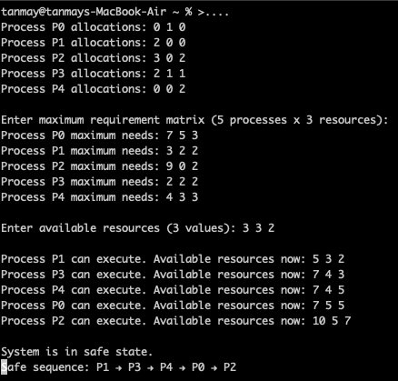

Copy:

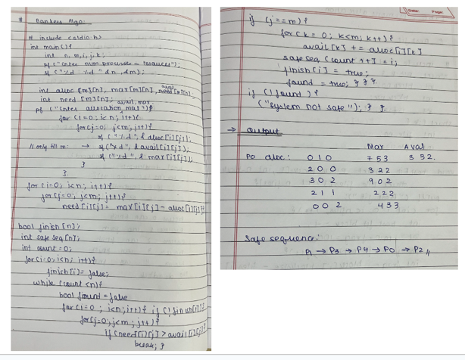

**Problem 8:**

Question

Write a C program to simulate deadlock detection

Code:

#include <stdio.h>

#include <stdbool.h>

int main() {

    int n, m; // Number of processes and resources

    // Get input sizes

    printf("Enter number of processes and resources: ");

    if(scanf("%d %d", &n, &m) != 2 || n <= 0 || m <= 0) {

        printf("Invalid input\n");

        return 1;

    }

    // Arrays for allocation, request, available and finish status

    int alloc[n][m], request[n][m], avail[m];

    bool finish[n];

    // Initialize finish array to false

    for(int i = 0; i < n; i++) {

        finish[i] = false;

    }

    // Input allocation matrix

    printf("Enter allocation matrix:\n");

    for(int i = 0; i < n; i++) {

        for(int j = 0; j < m; j++) {

            if(scanf("%d", &alloc[i][j]) != 1) {

                printf("Invalid input\n");

                return 1;

            }

        }

    }

    // Input request matrix

    printf("Enter request matrix:\n");

    for(int i = 0; i < n; i++) {

        for(int j = 0; j < m; j++) {

            if(scanf("%d", &request[i][j]) != 1) {

                printf("Invalid input\n");

                return 1;

            }

        }

    }

    // Input available resources

    printf("Enter available resources:\n");

    for(int i = 0; i < m; i++) {

        if(scanf("%d", &avail[i]) != 1) {

            printf("Invalid input\n");

            return 1;

        }

    }

    // CORRECTED: Mark processes with ALL zero allocations as finished

    for(int i = 0; i < n; i++) {

        bool all_zero = true;

        for(int j = 0; j < m; j++) {

            if(alloc[i][j] != 0) {

                all_zero = false;

                break;

            }

        }

        finish[i] = all_zero;

    }

    // Deadlock detection algorithm

    bool changed = true;

    int iterations = 0;

    const int max_iterations = n; // Prevent infinite loops

    while(changed && iterations < max_iterations) {

        changed = false;

        for(int i = 0; i < n; i++) {

            if(!finish[i]) {

                bool can_finish = true;

                // Check if request can be satisfied

                for(int j = 0; j < m; j++) {

                    if(request[i][j] > avail[j]) {

                        can_finish = false;

                        break;

                    }

                }

                if(can_finish) {

                    // Release resources

                    for(int j = 0; j < m; j++) {

                        avail[j] += alloc[i][j];

                    }

                    finish[i] = true;

                    changed = true;

                    printf("Process P%d can finish\n", i);

                }

            }

        }

        iterations++;

    }

    // Check for deadlock

    bool deadlock = false;

    for(int i = 0; i < n; i++) {

        if(!finish[i]) {

            deadlock = true;

            printf("Process P%d is deadlocked\n", i);

        }

    }

    if(deadlock) {

        printf("System is in deadlock state\n");

    } else {

        printf("System is not in deadlock state\n");

    }

    return 0;

}

Result:  
  
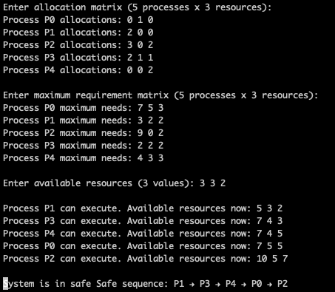

Tabhvaygxvusygvxs8

Copy:

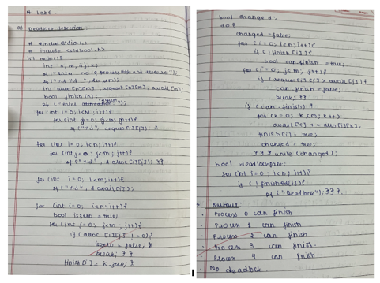

**Problem 9:**  
Question:

Write a C program to simulate the following contiguous memory allocation techniques

a) Worst-fit

1. Best-fit
2. First-fit

Code:

= > Best fit  
  
#include <stdio.h>

struct Block {

    int block_no;

    int block_size;

    int is_free;

};

struct File {

    int file_no;

    int file_size;

};

void bestFit(struct Block blocks[], int n_blocks, struct File files[], int n_files) {

    printf("\nMemory Management Scheme - Best Fit\n");

    printf("File_no\tFile_size\tBlock_no\tBlock_size\tFragment\n");

    for (int i = 0; i < n_files; i++) {

        int best_fit_block = -1;

        int min_fragment = 10000; // Large initial value

        for (int j = 0; j < n_blocks; j++) {

            if (blocks[j].is_free && blocks[j].block_size >= files[i].file_size) {

                int fragment = blocks[j].block_size - files[i].file_size;

                if (fragment < min_fragment) {

                    min_fragment = fragment;

                    best_fit_block = j;

                }

            }

        }

        if (best_fit_block != -1) {

            blocks[best_fit_block].is_free = 0;

            printf("%d\t%d\t\t%d\t\t%d\t\t%d\n",

                   files[i].file_no,

                   files[i].file_size,

                   blocks[best_fit_block].block_no,

                   blocks[best_fit_block].block_size,

                   min_fragment);

        } else {

            printf("%d\t%d\t\tNot Allocated\n", files[i].file_no, files[i].file_size);

        }

    }

}

int main() {

    int n_blocks, n_files;

    printf("Enter the number of blocks: ");

    scanf("%d", &n_blocks);

    struct Block blocks[n_blocks];

    for (int i = 0; i < n_blocks; i++) {

        blocks[i].block_no = i + 1;

        printf("Enter the size of block %d: ", i + 1);

        scanf("%d", &blocks[i].block_size);

        blocks[i].is_free = 1;

    }

    printf("Enter the number of files: ");

    scanf("%d", &n_files);

    struct File files[n_files];

    for (int i = 0; i < n_files; i++) {

        files[i].file_no = i + 1;

        printf("Enter the size of file %d: ", i + 1);

        scanf("%d", &files[i].file_size);

    }

    bestFit(blocks, n_blocks, files, n_files);

    return 0;

}

Result:  
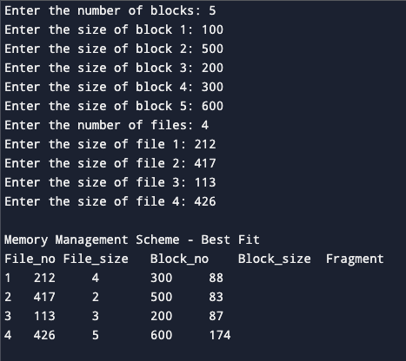

Copy:

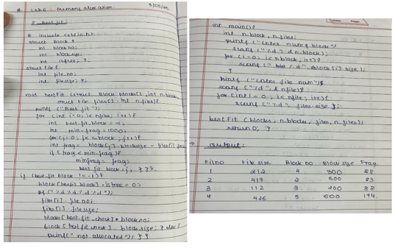

=> Worst fit:

Code:

#include <stdio.h>

// Structure to represent a memory block

struct Block {

int block_no;

int block_size;

int is_free; // 1 = free, 0 = occupied

};

// Structure to represent a file

struct File {

int file_no;

int file_size;

};

// Worst Fit memory allocation function

void worstFit(struct Block blocks[], int n_blocks, struct File files[], int n_files) {

printf("\nMemory Management Scheme - Worst Fit\n");

printf("File_no\tFile_size\tBlock_no\tBlock_size\tFragment\n");

for (int i = 0; i < n_files; i++) {

int worst_fit_block = -1;

int max_fragment = -1;

// Find the block with the largest leftover space

for (int j = 0; j < n_blocks; j++) {

if (blocks[j].is_free && blocks[j].block_size >= files[i].file_size) {

int fragment = blocks[j].block_size - files[i].file_size;

if (fragment > max_fragment) {

max_fragment = fragment;

worst_fit_block = j;

}

}

}

// Allocate if suitable block found

if (worst_fit_block != -1) {

blocks[worst_fit_block].is_free = 0;

printf("%d\t%d\t\t%d\t\t%d\t\t%d\n",

files[i].file_no,

files[i].file_size,

blocks[worst_fit_block].block_no,

blocks[worst_fit_block].block_size,

max_fragment);

} else {

printf("%d\t%d\t\tNot Allocated\n", files[i].file_no, files[i].file_size);

}

}

}

int main() {

int n_blocks, n_files;

// Input number of blocks and their sizes

printf("Enter the number of blocks: ");

scanf("%d", &n_blocks);

struct Block blocks[n_blocks];

for (int i = 0; i < n_blocks; i++) {

blocks[i].block_no = i + 1;

printf("Enter the size of block %d: ", i + 1);

scanf("%d", &blocks[i].block_size);

blocks[i].is_free = 1;

}

// Input number of files and their sizes

printf("Enter the number of files: ");

scanf("%d", &n_files);

struct File files[n_files];

for (int i = 0; i < n_files; i++) {

files[i].file_no = i + 1;

printf("Enter the size of file %d: ", i + 1);

scanf("%d", &files[i].file_size);

}

// Run Worst Fit Allocation

worstFit(blocks, n_blocks, files, n_files);

return 0;

}

Result:

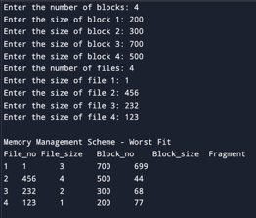

Copy:

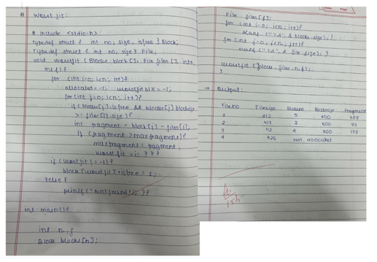  
  
**=> First fit:**

Code:

#include <stdio.h>

// Structure to represent a memory block

struct Block {

int block_no;

int block_size;

int is_free; // 1 = free, 0 = occupied

};

// Structure to represent a file

struct File {

int file_no;

int file_size;

};

// First Fit memory allocation function

void firstFit(struct Block blocks[], int n_blocks, struct File files[], int n_files) {

printf("\nMemory Management Scheme - First Fit\n");

printf("File_no\tFile_size\tBlock_no\tBlock_size\tFragment\n");

for (int i = 0; i < n_files; i++) {

int allocated = 0;

// Allocate the first available block that fits the file

for (int j = 0; j < n_blocks; j++) {

if (blocks[j].is_free && blocks[j].block_size >= files[i].file_size) {

int fragment = blocks[j].block_size - files[i].file_size;

blocks[j].is_free = 0;

printf("%d\t%d\t\t%d\t\t%d\t\t%d\n",

files[i].file_no,

files[i].file_size,

blocks[j].block_no,

blocks[j].block_size,

fragment);

allocated = 1;

break; // Stop after first suitable block

}

}

// If no suitable block found

if (!allocated) {

printf("%d\t%d\t\tNot Allocated\n", files[i].file_no, files[i].file_size);

}

}

}

int main() {

int n_blocks, n_files;

// Input number of blocks and their sizes

printf("Enter the number of blocks: ");

scanf("%d", &n_blocks);

struct Block blocks[n_blocks];

for (int i = 0; i < n_blocks; i++) {

blocks[i].block_no = i + 1;

printf("Enter the size of block %d: ", i + 1);

scanf("%d", &blocks[i].block_size);

blocks[i].is_free = 1;

}

// Input number of files and their sizes

printf("Enter the number of files: ");

scanf("%d", &n_files);

struct File files[n_files];

for (int i = 0; i < n_files; i++) {

files[i].file_no = i + 1;

printf("Enter the size of file %d: ", i + 1);

scanf("%d", &files[i].file_size);

}

// Run First Fit Allocation

firstFit(blocks, n_blocks, files, n_files);

return 0;

}

Result:  
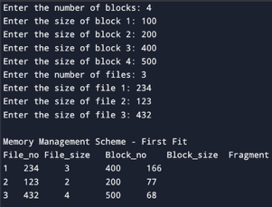

Copy:

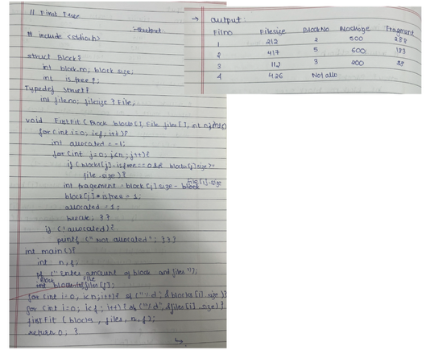

**Problem 10:**  
Question Write a C program to simulate page replacement algorithms

1. FIFO
2. LRU
3. Optimal

= > Fifo

Code:

#include <stdio.h>

int main() {

    int n, frames, i, j, k, found, index = 0, page_faults = 0, hits = 0;

    char pages[100];

    printf("Enter the size of the pages:\n");

    scanf("%d", &n);

    printf("Enter the page strings:\n");

    scanf("%s", pages);

    printf("Enter the no of page frames:\n");

    scanf("%d", &frames);

    int mem[frames];

    for (i = 0; i < frames; i++) mem[i] = -1;

    for (i = 0; i < n; i++) {

        found = 0;

        for (j = 0; j < frames; j++) {

            if (mem[j] == pages[i] - '0') {

                hits++;

                found = 1;

                break;

            }

        }

        if (!found) {

            mem[index] = pages[i] - '0';

            index = (index + 1) % frames;

            page_faults++;

        }

    }

    printf("FIFO Page Faults: %d, Page Hits: %d\n", page_faults, hits);

    return 0;

}

Result:

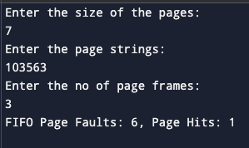

Copy:

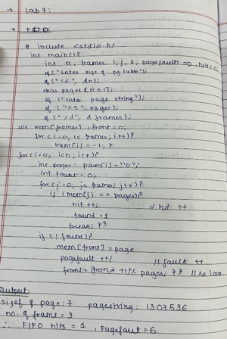

= > LRU :

Code:

#include <stdio.h>

int main() {

int n, frames, i, j, k, page_faults = 0, hits = 0;

printf("Enter the size of the pages:\n");

scanf("%d", &n);

char pages[n + 1];

printf("Enter the page strings:\n");

scanf("%s", pages);

printf("Enter the no of page frames:\n");

scanf("%d", &frames);

int mem[frames], last_used[frames];

for (i = 0; i < frames; i++) {

mem[i] = -1;

last_used[i] = -1;

}

for (i = 0; i < n; i++) {

int page = pages[i] - '0';

int found = 0;

for (j = 0; j < frames; j++) {

if (mem[j] == page) {

hits++;

last_used[j] = i;

found = 1;

break;

}

}

if (!found) {

int lru = 0;

for (j = 1; j < frames; j++) {

if (last_used[j] < last_used[lru]) {

lru = j;

}

}

mem[lru] = page;

last_used[lru] = i;

page_faults++;

}

}

printf("LRU Page Faults: %d, Page Hits: %d\n", page_faults, hits);

return 0;

}

Result:

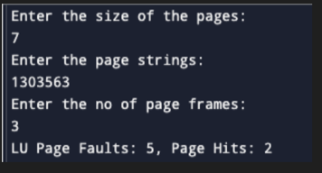

Copy:

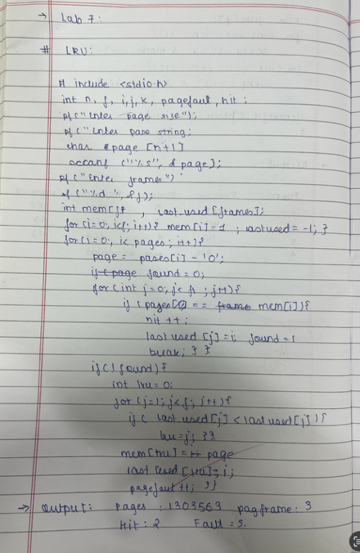

=> Optimal   
  
Code:

#include <stdio.h>

int main() {

int n, frames, i, j, k, page_faults = 0, hits = 0;

printf("Enter the size of the pages:\n");

scanf("%d", &n);

char pages[n + 1];

printf("Enter the page strings:\n");

scanf("%s", pages);

printf("Enter the no of page frames:\n");

scanf("%d", &frames);

int mem[frames], next_use[frames];

for (i = 0; i < frames; i++) {

mem[i] = -1;

}

for (i = 0; i < n; i++) {

int page = pages[i] - '0';

int found = 0;

for (j = 0; j < frames; j++) {

if (mem[j] == page) {

hits++;

found = 1;

break;

}

}

if (!found) {

if (page_faults < frames) {

mem[page_faults++] = page;

} else {

for (j = 0; j < frames; j++) {

next_use[j] = -1;

for (k = i + 1; k < n; k++) {

if (mem[j] == pages[k] - '0') {

next_use[j] = k;

break;

}

}

}

int farthest = 0;

for (j = 1; j < frames; j++) {

if (next_use[j] > next_use[farthest]) {

farthest = j;

}

}

mem[farthest] = page;

page_faults++;

}

}

}

printf("Optimal Page Faults: %d, Page Hits: %d\n", page_faults, hits);

return 0;

}

Result :

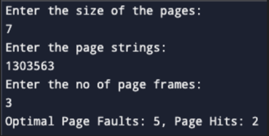

Copy:

